
SUMMER TRAINING/INTERNSHIP
PROJECT REPORT
(Term June-July 2025)
TITLE OF THE PROJECT :
RitualFuel – A Wellness Tracking Android App
Submitted by
Moturi Sai Dinesh
Registration Number : 12304264
Course Code : PETV75
Under the Guidance of
Amanpreet Madam (UID: 31986)
School of Computer Science and Engineering

CERTIFICATE



ACKNOWLEDGEMENT
I would like to express my heartfelt gratitude to all those who guided and supported me throughout my summer training/internship project. My sincere thanks to my internal mentor Amanpreet Madam , and all the faculty members for their valuable suggestions and guidance.

Table of Contents
CHAPTER 1 5
INTRODUCTION 5
CHAPTER 2 6
TRAINING OVERVIEW 6
CHAPTER 3 7
PROJECT DETAILS 7
CHAPTER 4 8
IMPLEMENTATION 8
CHAPTER 5 17
RESULTS AND DISCUSSION 17
CHAPTER 6 18
CONCLUSION 18

CHAPTER 1

INTRODUCTION
Company Profile
The project was developed as part of academic training under guidance and self-research. It simulates a wellness-focused Android application titled RitualFuel, aimed at promoting daily mindfulness, healthy habits, and productivity through mobile technology.
Overview of Training Domain
The project falls under the domain of Mobile App Development using Android. It leverages concepts of Java/Kotlin programming, XML-based UI design, backend logic, and user experience (UX) principles to deliver a meaningful wellness tool.
Objective of the Project
The primary objective of RitualFuel is to help users achieve mental clarity, motivation, and healthy consistency by tracking daily interactions with content such as Yoga tutorials, Health Tips, and GK Questions. It also introduces a streak system to gamify personal wellness.

CHAPTER 2

TRAINING OVERVIEW
Tools & Technologies Used
- Android Studio (IDE)
- Kotlin & Java (Programming Languages)
- XML (UI Design)
- ViewPager2 (Image Slider)
- SharedPreferences (Streak tracking)
- Material Components (UI)
- Firebase (optional) for future scaling
Areas Covered During Training
- XML-based layout design
- Android Activity lifecycle
- Navigation Drawer and Toolbar integration
- User Authentication UI
- Image sliders and background threading
- Persistent data storage using SharedPreferences
- Toast notifications and intent-based navigation
Daily/Weekly Work Summary
- Week 1: Basic app layout, splash screen, login & register pages
- Week 2: Home page with feature cards and navigation drawer
- Week 3: Image slider and streak tracking logic
- Week 4: Testing, debugging, and polishing UI
- Week 5: Documentation structure

CHAPTER 3

PROJECT DETAILS
Title of the Project
RitualFuel – A Wellness Tracking Android App
Problem Definition
Many users lack daily motivation and consistency in wellness routines like yoga, meditation, and reading. RitualFuel solves this with a friendly mobile interface that guides, encourages, and rewards consistency.
Scope and Objectives
- Provide daily content like Yoga videos and Health Tips
- Track user interaction and maintain a daily streak system
- Help users stay motivated with a clear and aesthetic UI
- Enable login and sign-up for personalized usage
System Requirements
- Android OS: Minimum SDK 21 (Lollipop)
- RAM: Minimum 2GB
- Internet: Optional for embedded content
- Storage: ~20MB app size

Data Flow / UML Diagrams
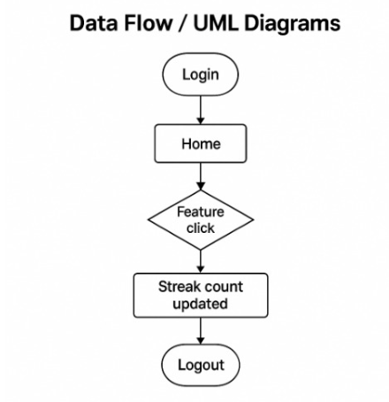

CHAPTER 4

IMPLEMENTATION
Tools Used
- Android Studio
- Kotlin (Java interoperability used)
- Vector assets and drawable resources
- SharedPreferences API
Methodology
The app was implemented using the Modular Approach. Each activity (e.g., Welcome, Login, Home, etc.) was developed and tested independently before integration.
Modules / Screenshots
1. Welcome Screen
Peaceful screen introducing RitualFuel with a meditation-themed image and a Get Started button.
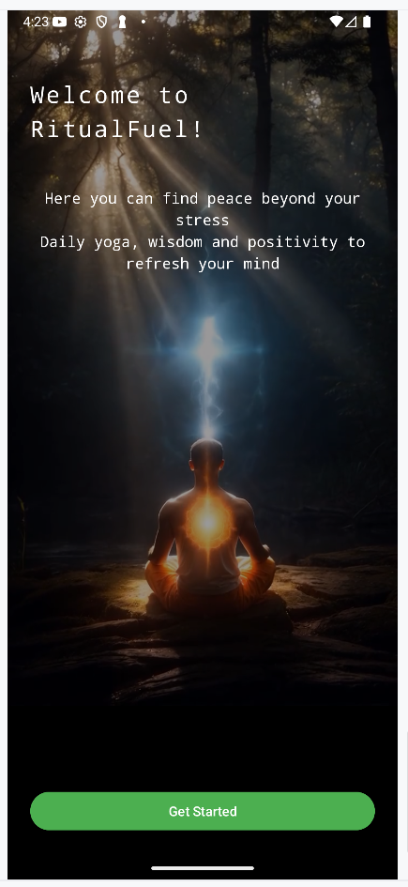
2. Login Screen
Clean login form with Email, Password, Forgot Password link, and navigation to Register.
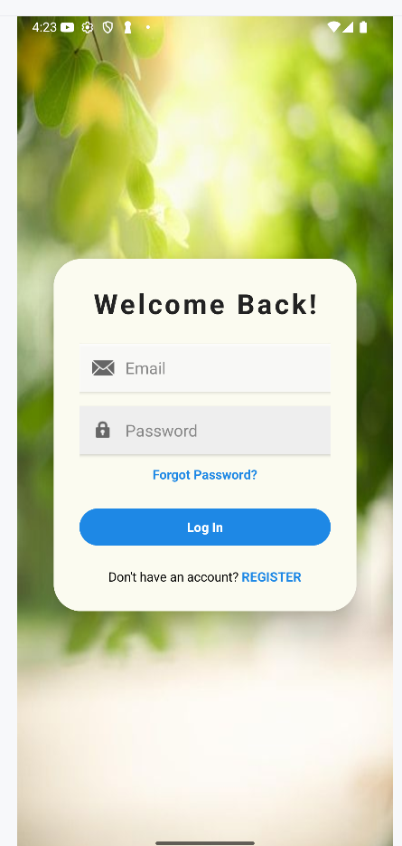

3. Register Screen
A calm green-themed form for new users with social login options (Facebook, Google, Apple).
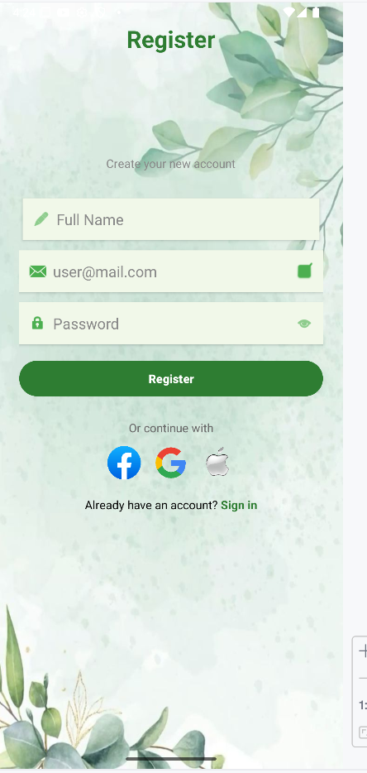
4. Home Screen
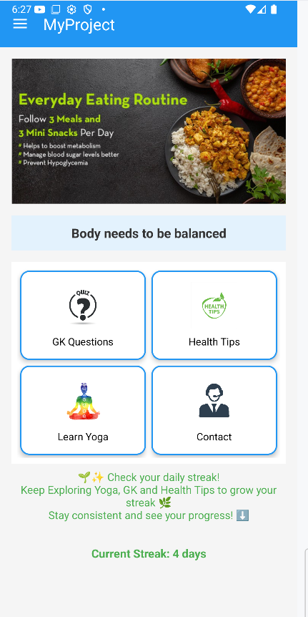

Contains 4 main buttons:
- GK Questions
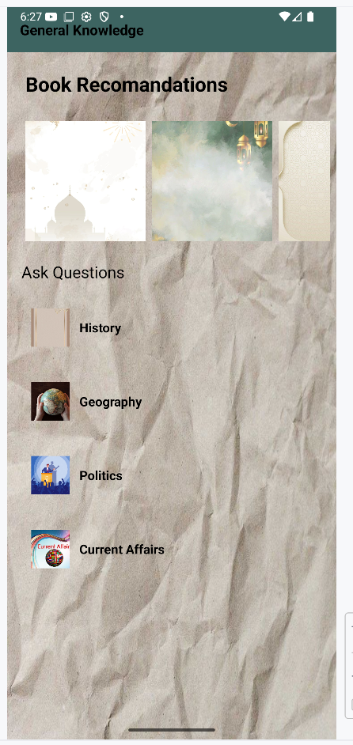

- Health Tips
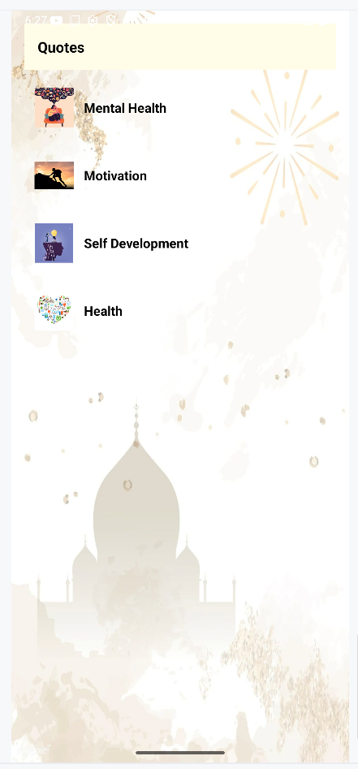

- Learn Yoga
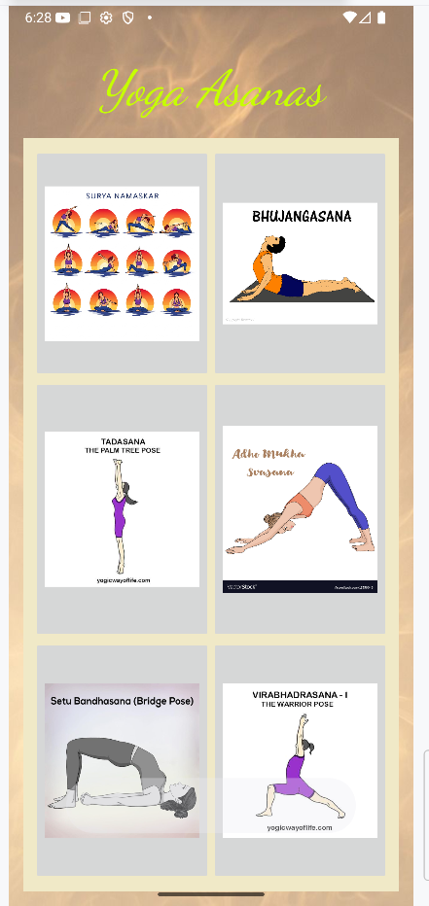

- Contact
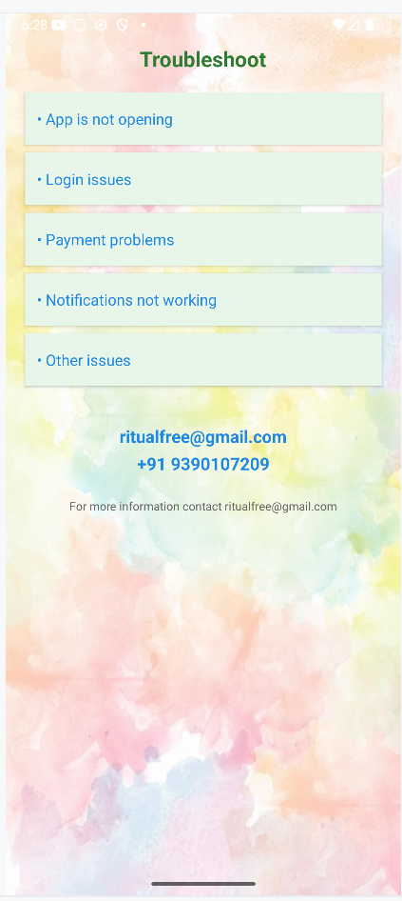
It also includes:
- Streak TextView: “Current Streak: 4 days”
- Motivational Toasts: When you click on GK, Health, or Yoga, a toast appears:
" Task completed. Keep going!"

CHAPTER 5

RESULTS AND DISCUSSION
Output
- User can register, login, and land on home dashboard.
- Image slider runs smoothly.
- Streak text updates in real-time.
- App is stable on most Android devices.
Challenges Faced
- Managing streaks in a user-friendly way
- Designing responsive layouts for all screen sizes
- Debugging navigation flows and shared preferences
Learnings
- Practical knowledge of Android components
- Use of Kotlin with real-time feedback using Toasts
- XML design principles for responsive UI
- SharedPreferences for local data persistence

CHAPTER 6

CONCLUSION
The project “RitualFuel” successfully demonstrates the ability to build a modular, real-world Android app focused on wellness and motivation. With its visually engaging UI and logical streak system, the app encourages daily self-improvement habits through yoga, learning, and health awareness.
This training enhanced practical development skills and improved understanding of Android application structure and user-centered design.

